A Comparative Study of Flagship Bird Community Resilience and Environmental Responses in China and the United States

Yiyi Deng
Pioneer Academics Research Program
Faculty Mentor: Jim Kahn
August 2026

Abstract
Climate change is reshaping global ecological patterns, challenging conventional static approaches to biodiversity conservation. Using China and the United States as contrasting conservation contexts, we modeled the habitat suitability of 18 flagship bird species in each country with MaxEnt, a species distribution model that uses species occurrence data and environmental variables to predict habitat suitability, to develop a multidimensional framework of avian community resilience. Being defined as a bird community’s ability to withstand environmental changes, I examined its future dynamics, environmental responses, and climate refugia under different climate scenarios.
The results showed that: 1) avian community resilience differed substantially between the two countries, with non-resilient areas dominating China and extensive resilient areas occurring in the United States; however, both countries showed pronounced degradation under high climate forcing. 2) Resilience was primarily driven by individual environmental factors in China but by complex climatic interactions in the United States, with significant nonlinear thresholds and buffering effects associated with hydrothermal conditions and high-elevation environments. 3) Climate refugia in both countries showed a general shift toward higher latitudes and major mountain systems, while low-latitude potential refugia underwent substantial contraction.
Overall, these findings reveal contrasting capacities of spatial conservation patterns to buffer climate stress and provide a scientific basis for forward-looking transnational biodiversity conservation under climate change.

Key words: climate change, bird communities resilience, climate refugia, nature-based resolutions

Table of Contents
- Introduction 3
2. Research methods 4
2.1 Study Area 4
2.2 Acquisition and Screening of Species Occurrence Records and Environmental Variables 5
2.3 Species Distribution Modeling and Model Evaluation 8
2.4 Bird Community Resilience Analysis 9
2.5 Identification of Climate Refugia for Bird Communities in China and the United States 11
3. Results 13
3.1 Evaluation of MaxEnt Model Performance 13
3.2 Bird Community Resilience under Different Climate Scenarios 14
3.3 Nonlinear Environmental Response of Bird Community Resilience 17
3.4 Identification of Climate Refugia for Bird Community Resilience in China and the United States 21
4. Discussion 23
5. Conclusion 25
6. References (tentative) 26

Introduction
During the Anthropocene, climate change has become one of the most important drivers reshaping global biodiversity conservation policies (BirdLife International, n.d). Rapid shifts in temperature and precipitation, together with accelerating habitat loss, are forcing governments to reconsider how protected areas should be designed and managed. China and the United States are no exception, as both countries have incorporated climate adaptation into their long-term biodiversity conservation strategies.
Although biodiversity conservation aims to protect entire ecosystems, directly monitoring all species is practically impossible because of the enormous diversity of taxa and the limited availability of long-term ecological data (Bowen-Jones & Entwistle, 2002). Consequently, conservation biology increasingly relies on representative indicators or flagship species to evaluate ecosystem responses to environmental change. Birds are particularly suitable because they are widely distributed, well studied, highly sensitive to habitat and climate change, and supported by extensive long-term monitoring datasets. Also, their population trends often mirror those of other taxa, making them excellent indicators of ecosystem health. (Hallmann et al, 2014). Insectivorous birds, in particular, often respond rapidly to changes in insect abundance and habitat quality (Hannah et al, 2007). Therefore, bird population trends provide valuable indicators of overall ecosystem condition. Flagship bird species, additionally, could attract public attention and social funds. (IPBES, 2019)
Traditional protected areas were generally established according to historical species distributions and existing biodiversity hotspots (Jenkins et al, 2013). However, climate change is rapidly altering habitat suitability, causing many species to shift their geographic ranges (Miller-Rushing et al, 2017). Consequently, areas that effectively conserve biodiversity today may no longer provide suitable habitats in the future. Conservation planning therefore needs to move beyond protecting current species distributions and adopt a forward-looking perspective that anticipates future habitat shifts. Identifying climate refugia—areas expected to remain climatically suitable despite future climate change—has become a key strategy for improving the long-term effectiveness of protected-area networks. (Morelli et al, 2020)
China and the United States represent two contrasting conservation systems. While the United States has a long history of protected-area development based on preserving wilderness, China’s protected-area network has expanded rapidly in recent days through national ecological planning (Schmeller et al, 2015). Given the pronounced contrasts between the two countries in environmental gradients and conservation patterns, this study systematically selected 18 flagship bird species from each country, encompassing six major functional groups: waterfowl, wading birds, raptors, terrestrial birds, climbing birds, and songbirds. By integrating multi-source remote sensing data, the MaxEnt model, and optimized machine-learning approaches, we aim to address the following research questions:
- How does avian community resilience vary spatially under different climate-change scenarios in China and the United States?
- How are climate refugia for avian communities spatially distributed across China and the United States?
- What are the policy implications of our study to China and the United States?
Through this research, we aim to demonstrate the differences in the effectiveness of contrasting spatial conservation strategies under climate-related stress and to provide a scientific basis for developing forward-looking and sustainable collaborative biodiversity conservation strategies between China and the United States.

Research methods

2.1 Study Area
China and the contiguous United States were selected as the comparative study areas in this research (Figure 1). Both countries span wide latitudinal and longitudinal gradients and exhibit highly complex topography, covering a wide range of ecosystems from cold temperate to tropical regions and from arid deserts to high rainfall areas. Such remarkable spatial heterogeneity and climatic diversity not only provide essential habitats and migration corridors for different groups of flagship bird species (Duan H et al, 2026; Dong J et al, 2025), but also make these regions ideal geographical samples for exploring ecological response mechanisms under large-scale climate change. In addition, China and the United States represent two typical paradigms in the evolution of protected-area networks. The U.S. system was established earlier but is characterized by a highly fragmented spatial pattern (Kroner R E G et al, 2016), whereas China has implemented systematic spatial restructuring through the Ecological Conservation Redline policy (Mi C et al, 2023). Comparing these two countries provides an opportunity to reveal differences in the effectiveness of environmental gradients and protected-area configurations in buffering climate stress and maintaining the functional resilience of bird communities.
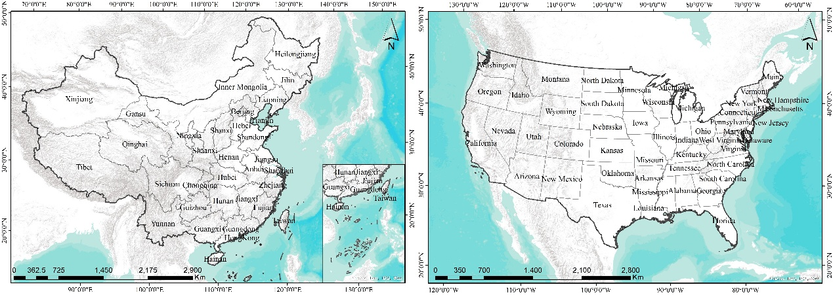
Figure 1. Overview of the study areas
(Source: original analysis by author)

2.2 Acquisition and Screening of Species Occurrence Records and Environmental Variables
To comprehensively evaluate changes in bird community resilience, occurrence records of representative flagship bird species in China and the United States from 2000 to the present were obtained from the Global Biodiversity Information Facility (GBIF; https://www.gbif.org/) (Dasgupta S et al, 2024). To ensure data reliability, only human observation records and machine observation records (including infrared cameras, automated acoustic recorders, automated sensors, etc) from the public database were retained, and all occurrence records located within impervious surface grids were removed (Sun Z et al, 2025). In addition, duplicate records of the same species within the same 5 km × 5 km grid cell were removed to avoid model overfitting (Hughes A C et al, 2021). Only species with at least 15 occurrence records after data filtering were included for habitat suitability modeling (Luan J et al, 2020). Finally, habitat suitability models were developed for 18 flagship bird species in each country (China: 5,415 occurrence records; United States: 1,249,975 occurrence records).
Bird species distribution modelling in China |  |  | Bird species distribution modelling in the U.S
Species | Taxon | Number of occurrence records | Species | Taxon | Number of occurrence records
Mergus squamatus | Waterfowl | 179 | Anser canagicus | Waterfowl | 85
Anser cygnoides | Waterfowl | 720 | Histrionicus histrionicus | Waterfowl | 454
Aythya baeri | Waterfowl | 270 | Polysticta stelleri | Waterfowl | 16
Nipponia nippon | Wading bird | 112 | Grus americana | Wading bird | 355
Grus japonensis | Wading bird | 140 | Aramus guarauna | Wading bird | 3378
Calidris pygmaea | Wading bird | 63 | Charadrius melodus | Wading bird | 2331
Paradoxornis heudei | Passerine (Songbird) | 273 | Aphelocoma coerulescens | Passerine (Songbird) | 610
Garrulax canorus | Passerine (Songbird) | 418 | Setophaga kirtlandii | Passerine (Songbird) | 89
Emberiza aureola | Passerine (Songbird) | 74 | Leucosticte australis | Passerine (Songbird) | 943
Aquila chrysaetos | Raptor | 671 | Micrathene whitneyi | Raptor | 839
Gyps himalayensis | Raptor | 1052 | Gymnogyps californianus | Raptor | 68
Accipiter gentilis | Raptor | 29 | Rostrhamus sociabilis | Raptor | 1060
Chrysolophus pictus | Terrestrial bird | 224 | Centrocercus urophasianus | Terrestrial bird | 3834
Otis tarda | Terrestrial bird | 139 | Tympanuchus cupido | Terrestrial bird | 289
Syrmaticus ellioti | Terrestrial bird | 86 | Bonasa umbellus | Terrestrial bird | 1266
Dryocopus martius | Climbing bird | 138 | Leuconotopicus borealis | Climbing bird | 1819
Ceryle rudis | Climbing bird | 810 | Melanerpes uropygialis | Climbing bird | 3084
Anthracoceros albirostris | Climbing bird | 17 | Picoides dorsalis | Climbing bird | 5217
Table 1. List of modeled flagship bird species in China and the United States.
(Source: original analysis by author)
Based on the ecological requirements of bird habitat selection under climate change (Gelete T B et al, 2025; Dragonetti C et al, 2024), a total of 20 environmental variables were selected for species distribution modeling, including the 19 bioclimatic variables from WorldClim (Bio1–Bio19) and elevation. ArcGIS 10.8 was used to standardize the coordinate system, spatial resolution, and spatial extent of all environmental variables. Considering computational efficiency and data storage requirements, a spatial resolution of 5 km was adopted for species distribution modeling. To reduce model overfitting, ased on the work of Ji (2025), the usdm and terra packages in R were used to perform Variance Inflation Factor (VIF) and Pearson correlation analyses for all environmental variables. Variables with VIF ≥ 10 and |r| ≥ 0.8 were excluded (Figure 2). Finally, Bio2, Bio3, Bio4, Bio8, Bio9, Bio14, Bio15, and Bio18 were retained for China, while Bio2, Bio4, Bio8, Bio9, Bio10, Bio13, Bio14, Bio15, Bio18, and elevation were retained for the United States.
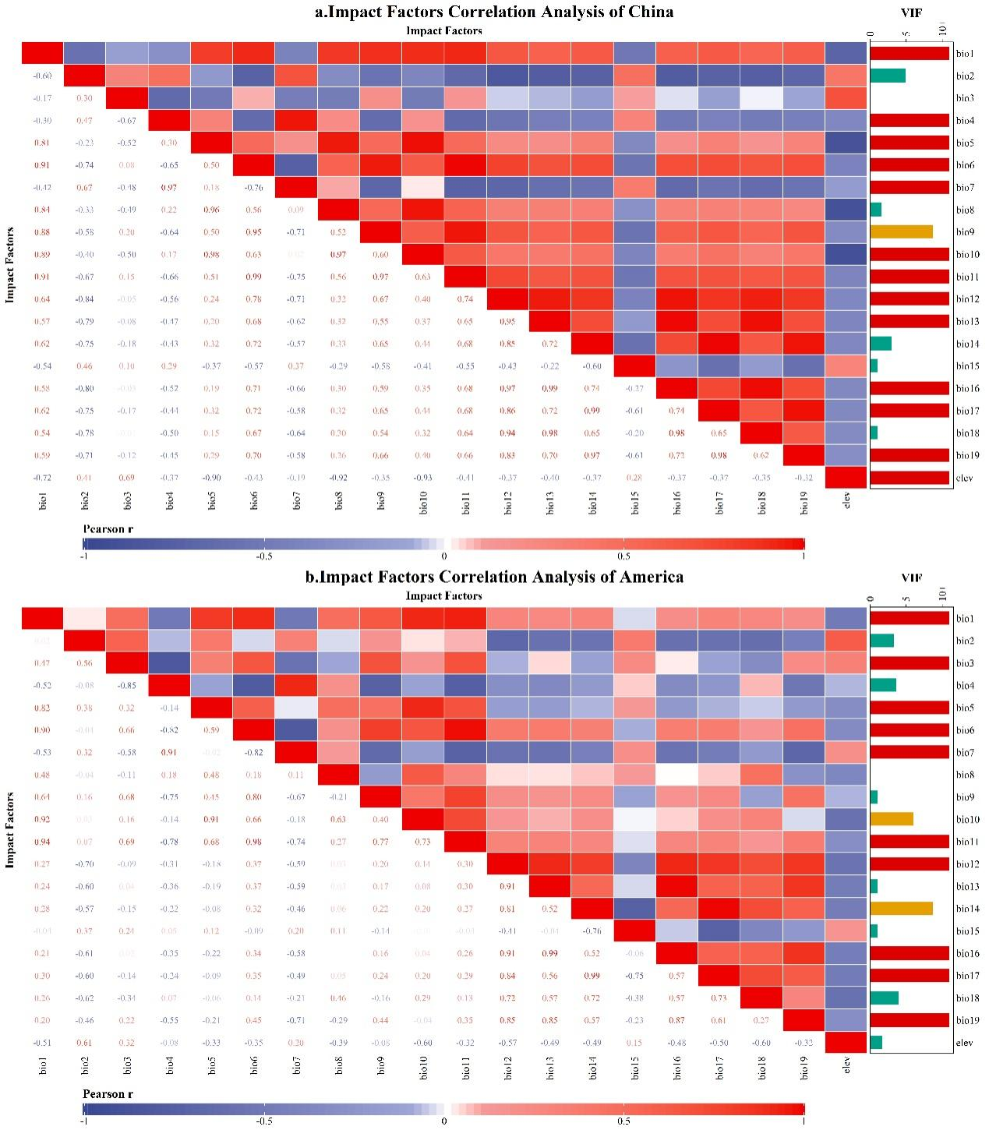
Figure 2. Correlation analysis of selected environmental variables in China and the United States.
(Source: original analysis by author)
Code | Climate Variable | Description | Unit
BIO2 | Mean Diurnal Range | Mean of monthly maximum temperature-minimum temperature | °C
BIO3 | Isothermality | BIO2/BIO7 * 100 | %
BIO4 | Temporal Seasonality | Standard deviation of annual temperature | %
BIO8 | Mean Temperature of Wettest Quarter | Mean temperature during the wettest quarter | °C
BIO9 | Mean Temperature of Driest Quarter | Mean temperature during the driest quarter | °C
BIO10 | Mean Temperature of Warmest Quarter | Mean temperature during the warmest quarter | °C
BIO13 | Precipitation of Wettest Month | Total precipitation of the wettest month | mm
BIO14 | Precipitation of Driest Month | Total precipitation of the driest month | mm
BIO15 | Precipitation Seasonality | Coefficient of variation of monthly precipitation | %
BIO18 | Precipitation of Warmest Quarter | Total precipitation of the warmest month | mm
Elevation | Elevation | Height above sea level | m
Table 2. Climatic and topographic variables used in the study
(Source: original analysis by author)

2.3 Species Distribution Modeling and Model Evaluation
Species distribution models (SDMs) were used to estimate the habitat suitability of each bird species based on its observed occurrence records and environmental conditions. SDMs are ecological modeling approaches that characterize the relationship between species occurrence and environmental variables and use these relationships to predict the potential geographic distribution of species (Guisan & Zimmermann, 2000). In this study, the maximum entropy (MaxEnt) model was employed as the SDM algorithm because it is particularly suitable for presence-only occurrence data (Phillips et al., 2004; Phillips et al., 2006). MaxEnt estimates the probability distribution of species occurrence across geographic space by finding the distribution of maximum entropy subject to constraints derived from the environmental conditions at known occurrence locations.
Seventy-five percent of the occurrence records were randomly selected as the training dataset, while the remaining 25% were used as the testing dataset for model validation (Luo M et al, 2017). The model was replicated ten times with a maximum of 500 iterations. The relative contribution of each environmental variable was evaluated using the Jackknife test. Logistic output format was selected, while all other parameters were kept at their default settings.Model performance was evaluated using the Area Under the Receiver Operating Characteristic Curve (AUC) (Merrow C et al, 2013). AUC values range from 0 to 1, with higher values indicating better predictive performance. The evaluation criteria were as follows: 0.5–0.6, failed prediction; 0.6–0.7, poor; 0.7–0.8, fair; 0.8–0.9, good; and 0.9–1.0, excellent (West A M et al, 2016; Zhang Y et al, 2021).
The logistic output generated by MaxEnt ranged from 0 to 1, representing the suitability of each location for a given bird species, where values closer to 1 indicate more suitable habitat. These outputs were then processed in ArcGIS 10.8, where the suitability maps for individual species were put to the same geographic grid and combined to evaluate the overall resilience of the bird community in each grid cell.
Habitat suitability maps were reclassified using the Maximum Test Sensitivity Plus Specificity (MTSS) threshold (Liu C et al, 2005; Ramos R.S et al, 2019; Li D et al, 2022 ). Grid cells with logistic suitability values above the MTSS threshold were classified as suitable habitat, whereas the remaining grid cells were classified as unsuitable habitat. The maps will be shown in the 3.4 section

2.4 Bird Community Resilience Analysis
To quantify Avian Community Resilience (ACR), an index was developed from a functional ecology perspective based on Functional Redundancy (FR) and Response Diversity (RD), which are very important figures for ecological stability and resilience (Baskin, 1998). The detailed formulas are shown in Table 2. FR refers to the number of species within each grid cell. Communities with higher FR are more likely to maintain ecosystem functions when individual species disappear under environmental stress because other species can compensate for the lost ecological functions (Carmona et al, 2021). In this study, FR was quantified as the number of species within each grid cell. RD describes the variation in species responses to environmental disturbances within a community. Communities with higher RD exhibit greater differences in species responses to climate change, thereby increasing their capacity to buffer ecosystem disturbances (Mori et al, 2013). RD was quantified by calculating pairwise differences in climate tolerance among species within each grid cell.
Climate Tolerance (CT) was defined as the range of environmental conditions under which a species can survive. Based on the climatic variables used in the species distribution models, principal component analysis was performed, and CT was quantified as the weighted dispersion of species occurrence probabilities relative to their climatic optima in principal component space.
Metric | Formula | Description
Functional Redundancy, FR  （Source: Carmona et al, 2021） | $${FR}_{j}=\sum{P_{i,j}}$$ | The SDM-predicted probability value of species i in grid cell j.
Climate Tolerance, CT  （Source: Curtis et al, 2016） | $$CT=\sqrt{\frac{\sum_{j=1}^{N}{P_{i,j}×[{({PC1}_{j}−O_{i,PC1})}^{2}+{({PC2}_{j}−O_{i,PC2})}^{2}]}}{\sum_{j=1}^{N}{P_{i,j}}}}$$ | N represents the total number of grid cells within the study area; $P_{i,j}$ represents the SDM-predicted probability value of species i in grid cell j; ${PC1}_{j}$ and ${PC1}_{j}$ represent the reduced climatic principal component values of grid cell j; $O_{i,PC1}$ and $O_{i,PC2}$ represent the climatic optima of species i along the corresponding principal components, calculated as probability-weighted mean values.
Response Diversity, RD  （Source: Mori et al, 2013） | $${RD}_{j}=\frac{\sum_{i=1}^{S}{P_{i,j}^{2}×{({CT}_{i}−{\overline{CT}}_{j})}^{2}}}{\sum_{i=1}^{S}{P_{i,j}^{2}}}$$ | $\text{S} \text{represents the total number of species within the study area;}{\text{P}}_{\text{i}\text{,}\text{j}}$ represents the SDM-predicted probability value of species i in grid cell j；${\text{CT}}_{\text{i}}$ indicates the multidimensional climatic tolerance of species i; ${\overline{\text{CT}}}_{\text{j}}$ indicates the community-weighted mean climatic tolerance of grid cell j
Avian Community Resilience, ACR  （Source: Morelli et al, 2020） | $${\text{ACR}}_{\text{j}}\text{=}\sqrt[\text{3}]{{\text{FR}}_{\text{j}}^{\text{,}}\text{×}{\text{RD}}_{\text{j}}^{\text{,}}}$$ | ${\text{FR}}_{\text{j}}^{\text{,}}\text{、}{\text{RD}}_{\text{j}}^{\text{,}}$ represent the normalized values of functional redundancy (FR) and response diversity (RD) within grid cell j, respectively.
Table 3. Calculation of bird community resilience indices.
(Source: original analysis by author)
To eliminate differences in measurement scales and ensure spatial comparability, FR and RD were first normalized for each grid cell. “Normalized” refers to putting different variables onto a common scale so they can be fairly compared or combined. The normalized values were then combined using the geometric mean to calculate ACR. Based on previous studies (Wu L et al, 2021; Lu Z et al, 2026) and the characteristics of this study, ACR values under current and future climate scenarios were classified into four categories: high resilience (0.6–1.0), medium resilience (0.4–0.6), low resilience (0.2–0.4), and non-resilient areas (0–0.2).

2.5 Identification of Climate Refugia for Bird Communities in China and the United States
Unlike traditional climate refugia, which focus on long-term species persistence and population stability, resilience-based climate refugia are areas where communities can maintain their structure and ecosystem stability under climate change. Such areas not only satisfy the fundamental ecological niche requirements of species but also buffer against climatic stressors and enhance species’ adaptive and evolutionary potential.
To characterize the spatiotemporal heterogeneity, which refers to differences in patterns or processes across space and over time, and dynamic evolution of climate refugia, this study systematically classified refugia into three categories based on the succession patterns of avian community climate resilience under historical and future scenarios (current, 2050s, and 2090s).
(1) Stable refugia refer to areas that consistently maintain high community resilience throughout the entire study period (current, 2050s, and 2090s), serving as persistent core habitats that safeguard biodiversity against long-term climate risks.
(2) Transitional refugia refer to areas exhibiting high community resilience only during the mid-term period (2050s), while remaining in a non-high-resilience state under both the current and late-century (2090s) scenarios. These areas function as temporary ecological buffers that provide resilience during intermediate stages of climate change.
(3) Potential refugia refer to areas that attain a high community resilience state only under the late-century (2090s) scenario, representing future reserve habitats with the potential to support biodiversity under long-term climatic change.
For quantitative identification, and to focus on areas of the highest conservation value while minimizing statistical bias arising from differences in geographic extent and habitat area between China and the United States, the threshold for defining high community resilience was set as the top 10% of ACR values within each country for each evaluation period. Grid cells exceeding this country-specific threshold were classified as high-resilience areas and subsequently used to identify the three categories of climate refugia.

Results

3.1 Evaluation of MaxEnt Model Performance
The results showed that, after 10-fold cross-validation, the training and testing AUC values for all 18 bird species in China exceeded 0.85, while those for all 18 bird species in the United States exceeded 0.80 (Table 3). Overall, these results demonstrate that the MaxEnt model achieved strong predictive performance in simulating and predicting suitable habitats for bird species in both China and the United States, providing a reliable basis for subsequent analyses.
Bird species distribution modelling in China |  |  |  | Bird species distribution modelling in the U.S
Scientific name | Training AUC | Test AUC | AUC Standard Deviation | Scientific name | Training AUC | Test AUC | AUC Standard Deviation
Mergus squamatus | 0.95 | 0.94 | 0.0112 | Anser canagicus | 0.99 | 0.99 | 0.0027
Anser cygnoides | 0.90 | 0.89 | 0.0102 | Histrionicus histrionicus | 0.90 | 0.89 | 0.0127
Aythya baeri | 0.94 | 0.93 | 0.0113 | Polysticta stelleri | 1.00 | 0.76 | -1.0000
Nipponia nippon | 0.99 | 0.98 | 0.0062 | Grus americana | 0.86 | 0.84 | 0.0165
Grus japonensis | 0.96 | 0.96 | 0.0105 | Aramus guarauna | 0.87 | 0.87 | 0.0045
Calidris pygmaea | 0.99 | 0.99 | 0.0037 | Charadrius melodus | 0.87 | 0.87 | 0.0066
Paradoxornis heudei | 0.98 | 0.98 | 0.0045 | Aphelocoma coerulescens | 0.98 | 0.98 | 0.0017
Garrulax canorus | 0.96 | 0.96 | 0.0057 | Setophaga kirtlandii | 0.96 | 0.94 | 0.0174
Emberiza aureola | 0.96 | 0.94 | 0.0246 | Leucosticte australis | 0.96 | 0.96 | 0.0023
Aquila chrysaetos | 0.87 | 0.86 | 0.0129 | Micrathene whitneyi | 0.96 | 0.96 | 0.0024
Gyps himalayensis | 0.91 | 0.91 | 0.0063 | Gymnogyps californianus | 0.97 | 0.96 | 0.0157
Accipiter gentilis | 0.97 | 0.94 | 0.0397 | Rostrhamus sociabilis | 0.96 | 0.96 | 0.0024
Chrysolophus pictus | 0.97 | 0.97 | 0.0071 | Centrocercus urophasianus | 0.85 | 0.84 | 0.0041
Otis tarda | 0.97 | 0.95 | 0.0109 | Tympanuchus cupido | 0.94 | 0.93 | 0.0083
Syrmaticus ellioti | 0.99 | 0.99 | 0.0032 | Bonasa umbellus | 0.84 | 0.83 | 0.0073
Dryocopus martius | 0.96 | 0.95 | 0.0095 | Leuconotopicus borealis | 0.92 | 0.92 | 0.0034
Ceryle rudis | 0.94 | 0.93 | 0.0045 | Melanerpes uropygialis | 0.91 | 0.91 | 0.0030
Anthracoceros albirostris | 0.99 | 0.99 | 0.0036 | Picoides dorsalis | 0.83 | 0.84 | 0.0039
Table 4. Evaluation results of MaxEnt models
(Source: original analysis by author)

3.2 Bird Community Resilience under Different Climate Scenarios
IPCC describes SSP1 as a pathway with relatively sustainable development, SSP2 as a continuation of broadly current trends, and SSP5 as fossil-fueled development. We selected SSP1, SSP2, and SSP5 because they represent three contrasting levels of future climate forcing: low, intermediate, and high. This allows us to evaluate how avian community resilience changes as climate pressure progressively increases.
Under current climatic conditions, the spatial distribution patterns of avian community resilience (ACR) differed markedly between China and the United States. In terms of overall area, non-resilient regions dominated China, accounting for 50.56% of the total area, whereas resilient areas comprised less than half (49.44%). In contrast, resilient communities covered 90.81% of the United States, with non-resilient regions accounting for only 9.19%.This indicates that, under current climatic conditions, resilient bird communities occupy a much larger proportion of the United States than of China.
Spatially, resilient areas in China were primarily concentrated in the eastern and northeastern regions, with low-resilience areas predominating (32.60% of the total area). Moderate-resilience areas (16.30%) were mainly distributed across eastern, southern, and parts of northeastern China, whereas high-resilience areas occupied only 0.54% of the country and occurred as isolated patches in northern China and on southern offshore islands (Fig. 4a).
By comparison, the United States exhibited substantially broader resilience coverage. Extensive and contiguous moderate-resilience areas (44.76%) were widely distributed across the eastern and central regions, while pronounced clusters of high-resilience areas (4.07%) were identified along the southeastern coast and within the Rocky Mountains (Fig. 4b).
Proportion of areas with resilient bird communities in China  under current and future climate scenarios |  |  |  |  | Proportion of areas with resilient bird communities in the U.S  under current and future climate scenarios
Type | Climate Scenario | Time | Bird Population  Area（Km²） | Proportion | Type | Climate Scenario | Time | Bird Population  Area（Km²） | Proportion
Non-resilience area | — | Current | 4853760 | 50.56% | Non-resilience area | — | Current | 861103 | 9.19%
Low-resilience area | — | Current | 3129600 | 32.60% | Low-resilience area | — | Current | 3932589 | 41.97%
Medium-resilience area | — | Current | 1564800 | 16.30% | Medium-resilience area | — | Current | 4194012 | 44.76%
High-resilience area | — | Current | 51840 | 0.54% | High-resilience area | — | Current | 381359 | 4.07%
Non-resilience area | SSP1 | 2050 | 3980160 | 41.46% | Non-resilience area | SSP1 | 2050 | 687758 | 7.34%
Low-resilience area | SSP1 | 2050 | 4113600 | 42.85% | Low-resilience area | SSP1 | 2050 | 5004517 | 53.41%
Medium-resilience area | SSP1 | 2050 | 1501440 | 15.64% | Medium-resilience area | SSP1 | 2050 | 3511876 | 37.48%
High-resilience area | SSP1 | 2050 | 3840 | 0.04% | High-resilience area | SSP1 | 2050 | 165849 | 1.77%
Non-resilience area | SSP1 | 2090 | 3762240 | 39.19% | Non-resilience area | SSP1 | 2090 | 661522 | 7.06%
Low-resilience area | SSP1 | 2090 | 4010880 | 41.78% | Low-resilience area | SSP1 | 2090 | 4588489 | 48.97%
Medium-resilience area | SSP1 | 2090 | 1766400 | 18.40% | Medium-resilience area | SSP1 | 2090 | 3863251 | 41.23%
High-resilience area | SSP1 | 2090 | 60480 | 0.63% | High-resilience area | SSP1 | 2090 | 256738 | 2.74%
Non-resilience area | SSP2 | 2050 | 2936640 | 30.59% | Non-resilience area | SSP2 | 2050 | 827371 | 8.83%
Low-resilience area | SSP2 | 2050 | 4548480 | 47.38% | Low-resilience area | SSP2 | 2050 | 4908943 | 52.39%
Medium-resilience area | SSP2 | 2050 | 2040000 | 21.25% | Medium-resilience area | SSP2 | 2050 | 3443475 | 36.75%
High-resilience area | SSP2 | 2050 | 74880 | 0.78% | High-resilience area | SSP2 | 2050 | 190211 | 2.03%
Non-resilience area | SSP2 | 2090 | 2700480 | 28.13% | Non-resilience area | SSP2 | 2090 | 1030700 | 11.00%
Low-resilience area | SSP2 | 2090 | 4893120 | 50.97% | Low-resilience area | SSP2 | 2090 | 5005454 | 53.42%
Medium-resilience area | SSP2 | 2090 | 1960320 | 20.42% | Medium-resilience area | SSP2 | 2090 | 3167997 | 33.81%
High-resilience area | SSP2 | 2090 | 46080 | 0.48% | High-resilience area | SSP2 | 2090 | 165849 | 1.77%
Non-resilience area | SSP5 | 2050 | 2469120 | 25.72% | Non-resilience area | SSP5 | 2050 | 695254 | 7.42%
Low-resilience area | SSP5 | 2050 | 5175360 | 53.91% | Low-resilience area | SSP5 | 2050 | 4997021 | 53.33%
Medium-resilience area | SSP5 | 2050 | 1861440 | 19.39% | Medium-resilience area | SSP5 | 2050 | 3537175 | 37.75%
High-resilience area | SSP5 | 2050 | 94080 | 0.98% | High-resilience area | SSP5 | 2050 | 140550 | 1.50%
Non-resilience area | SSP5 | 2090 | 2248320 | 23.42% | Non-resilience area | SSP5 | 2090 | 1255580 | 13.40%
Low-resilience area | SSP5 | 2090 | 5652480 | 58.88% | Low-resilience area | SSP5 | 2090 | 4749653 | 50.69%
Medium-resilience area | SSP5 | 2090 | 1679040 | 17.49% | Medium-resilience area | SSP5 | 2090 | 3096785 | 33.05%
High-resilience area | SSP5 | 2090 | 20160 | 0.21% | High-resilience area | SSP5 | 2090 | 267982 | 2.86%
Table5. Area and proportion of bird community resilience under current and future climate scenarios in China and the United States
(Source: original analysis by author)
Under future climate change scenarios, avian community resilience (ACR) in both China and the United States exhibited pronounced spatiotemporal shifts and progressive degradation, with these trends becoming increasingly severe under stronger radiative forcing and over longer time horizons.
Under the SSP1 scenario, changes in ACR were relatively moderate. By the 2050s, moderate-resilience areas in southern China had begun to contract and transition into low-resilience areas, increasing the proportion of low-resilience regions nationwide to 42.85% (Fig. 4c). Similarly, moderate-resilience areas in the eastern United States underwent localized degradation, with their areal proportion declining to 37.48% (Fig. 4e). By the 2090s, the trend toward increasing low-resilience areas continued across China (Fig. 4d), while in the United States, high-resilience areas within the Rocky Mountains showed a slight reduction, accompanied by a modest expansion of non-resilient areas across the central and western regions (Fig. 4f).
Under the SSP2 scenario, the degradation of community resilience became considerably more pronounced. By the 2050s, moderate-resilience areas in southern and central China had contracted substantially, whereas scattered high-resilience patches emerged in parts of northern China (Fig. 4g). In the United States, extensive moderate-resilience areas in the eastern region experienced widespread degradation, resulting in an increase in the proportion of low-resilience areas to 52.39% (Fig. 4i). By the 2090s, moderate-resilience areas in southern China became increasingly fragmented, while high-resilience patches in northern China expanded and exhibited a clear northward shift toward higher latitudes (Fig. 4h). In contrast, high-resilience areas in the Rocky Mountains of the United States contracted markedly, accompanied by a substantial expansion of non-resilient areas across the central and western regions, which reached 11.00% of the total area (Fig. 4j).
Under the SSP5 scenario, the spatial patterns of ACR underwent dramatic reorganization in both countries. By the 2050s, moderate-resilience areas in southern China had largely degraded, whereas high-resilience clusters in northern China expanded markedly toward the northeast, with their areal proportion increasing to 0.98% (Fig. 4k). In the United States, high-resilience areas in the Rocky Mountains had nearly disappeared, reducing the overall proportion of high-resilience areas to 1.50%, while low-resilience conditions became increasingly widespread across the eastern region (Fig. 4m). By the 2090s, both countries exhibited severe degradation of community resilience. In China, extensive areas of southeastern China transitioned into low-resilience (58.88% of the total area) or non-resilient states, with the remaining high-resilience areas shifting predominantly toward higher latitudes (Fig. 4l). In other words, climate change significantly reduced resilience in southeastern China, while the remaining high-resilience areas became increasingly concentrated in northern regions. In the United States, except for a few persistent high-resilience patches in Florida, most of the country had degraded into low-resilience or non-resilient conditions. The proportion of non-resilient areas increased sharply to 13.40%, indicating a substantial decline in overall avian community resilience (Fig. 4n).
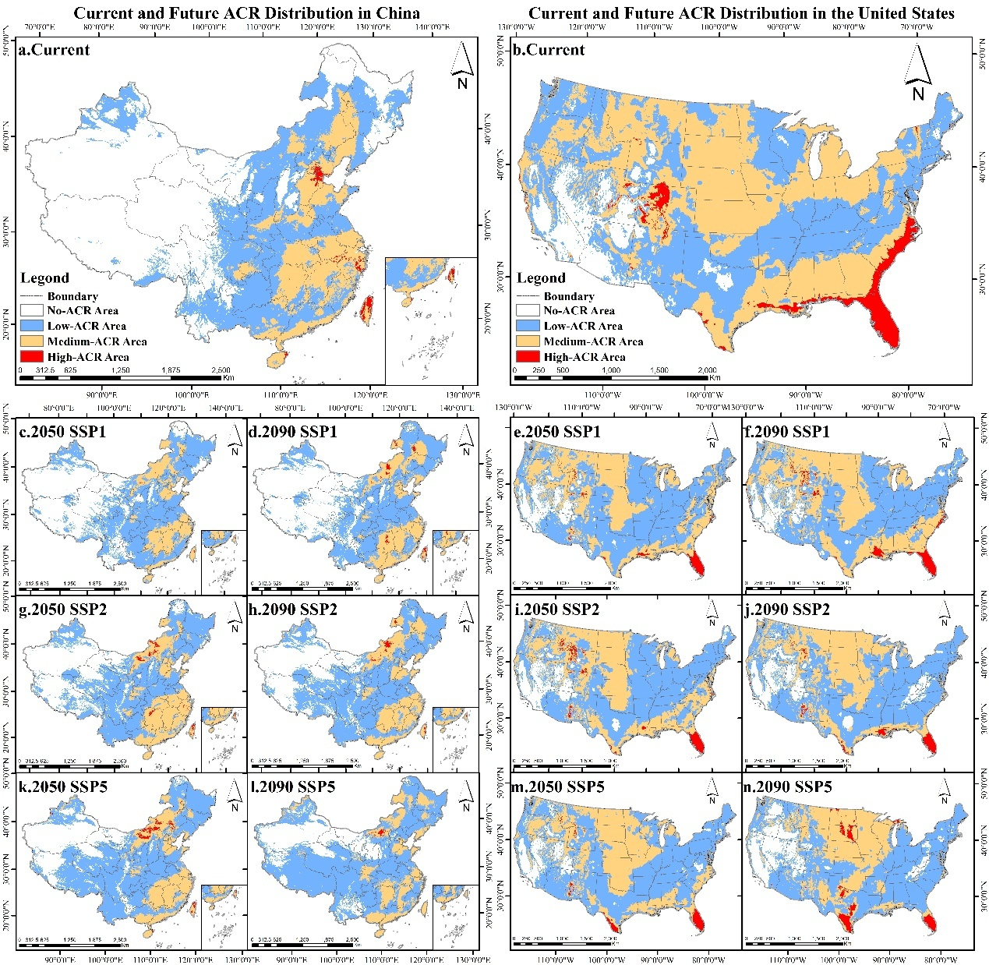
Figure 4. Bird community resilience under different climate scenarios (SSP1, SSP2, SSP5) in China and the United States
(Source: original analysis by author)

3.3 Nonlinear Environmental Response of Bird Community Resilience
For both China and the United States, Bio2, Bio4, Bio8, Bio9, Bio14, Bio15, and Bio18 were identified as common drivers of changes in avian community resilience (ACR). However, their underlying mechanisms differed markedly between the two countries. In China, ACR was predominantly influenced by the main effects of individual climatic variables, with only Bio4 and Bio15 exhibiting substantial interaction effects. In contrast, ACR in the United States was primarily governed by interactions among climatic variables, and no individual predictor showed a dominant main effect (Fig. 5).
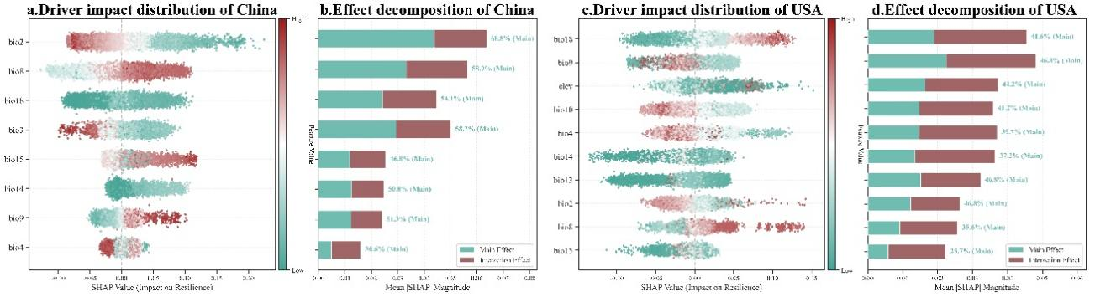
Figure 5. Contributions of environmental variables to bird community resilience in both China and the United States
(Source: original analysis by author)
SHAP partial dependence analysis of the environmental drivers of avian community resilience (ACR) in China and the United States revealed pronounced nonlinear relationships, threshold effects, and spatial heterogeneity. Most hydrothermal variables exhibited persistent unidirectional effects once critical thresholds were exceeded. For example, Bio18 and Bio8 consistently exerted increasingly positive effects on ACR after surpassing their respective thresholds (Bio18: 125 in China and 152 in the United States; Bio8: 19.2 in China and 15.9 in the United States), with the positive contributions strengthening as the variables increased (Fig. 6d, j). Likewise, the positive effect of Bio14 increased almost linearly beyond a threshold of 18.3 in China, whereas it rapidly reached a plateau after exceeding 18 in the United States (Fig. 6h). In contrast, Bio2 had a negative effect on ACR in both countries. Once Bio2 exceeded approximately 12.8 in China and 15 in the United States, higher values were increasingly associated with lower resilience. This suggests that excessive temperature variability may become increasingly stressful for bird communities beyond these thresholds (Fig. 6a). Bio3 (China only) and Bio10 (United States only) displayed a brief initial positive phase before transitioning into strong monotonic negative effects beyond thresholds of 0.3 and 20.2, respectively (Fig. 6b, f).
Several variables also exhibited complex nonlinear responses characterized by multiple threshold transitions. In the United States, Bio15 showed an inverted U-shaped response, reaching its maximum positive effect at 22.1 before becoming increasingly inhibitory beyond 66.2. By contrast, Bio15 in China followed a fluctuating “increase–decrease–increase” trajectory, reaching a minimum at 63 and rising sharply again after 152 (Fig. 6i). Similar reversals between positive and negative effects, accompanied by stage-specific attenuation, were also observed for Bio4 and Bio13 (Fig. 6c, g).
Among all variables, Bio9 exhibited the most pronounced inter-country differences. In China, its positive effect increased continuously after exceeding −5.65, whereas in the United States it displayed a typical niche-limitation pattern, with its positive contribution peaking at −2.37 before rapidly declining and ultimately becoming inhibitory (Fig. 6e). This contrast suggests fundamentally different tolerance strategies of avian communities to extremely cold and dry conditions between the two countries.
Regarding topographic effects, elevation (United States only) exhibited a distinct U-shaped relationship with ACR. Elevations between 175 and 2,090 m significantly reduced community resilience, whereas elevations above 2,090 m reversed this pattern and exerted a strong positive influence (Fig. 6k). This nonlinear transition suggests that, under intensified climatic stress, high-elevation regions may function as critical stable refugia for avian communities.
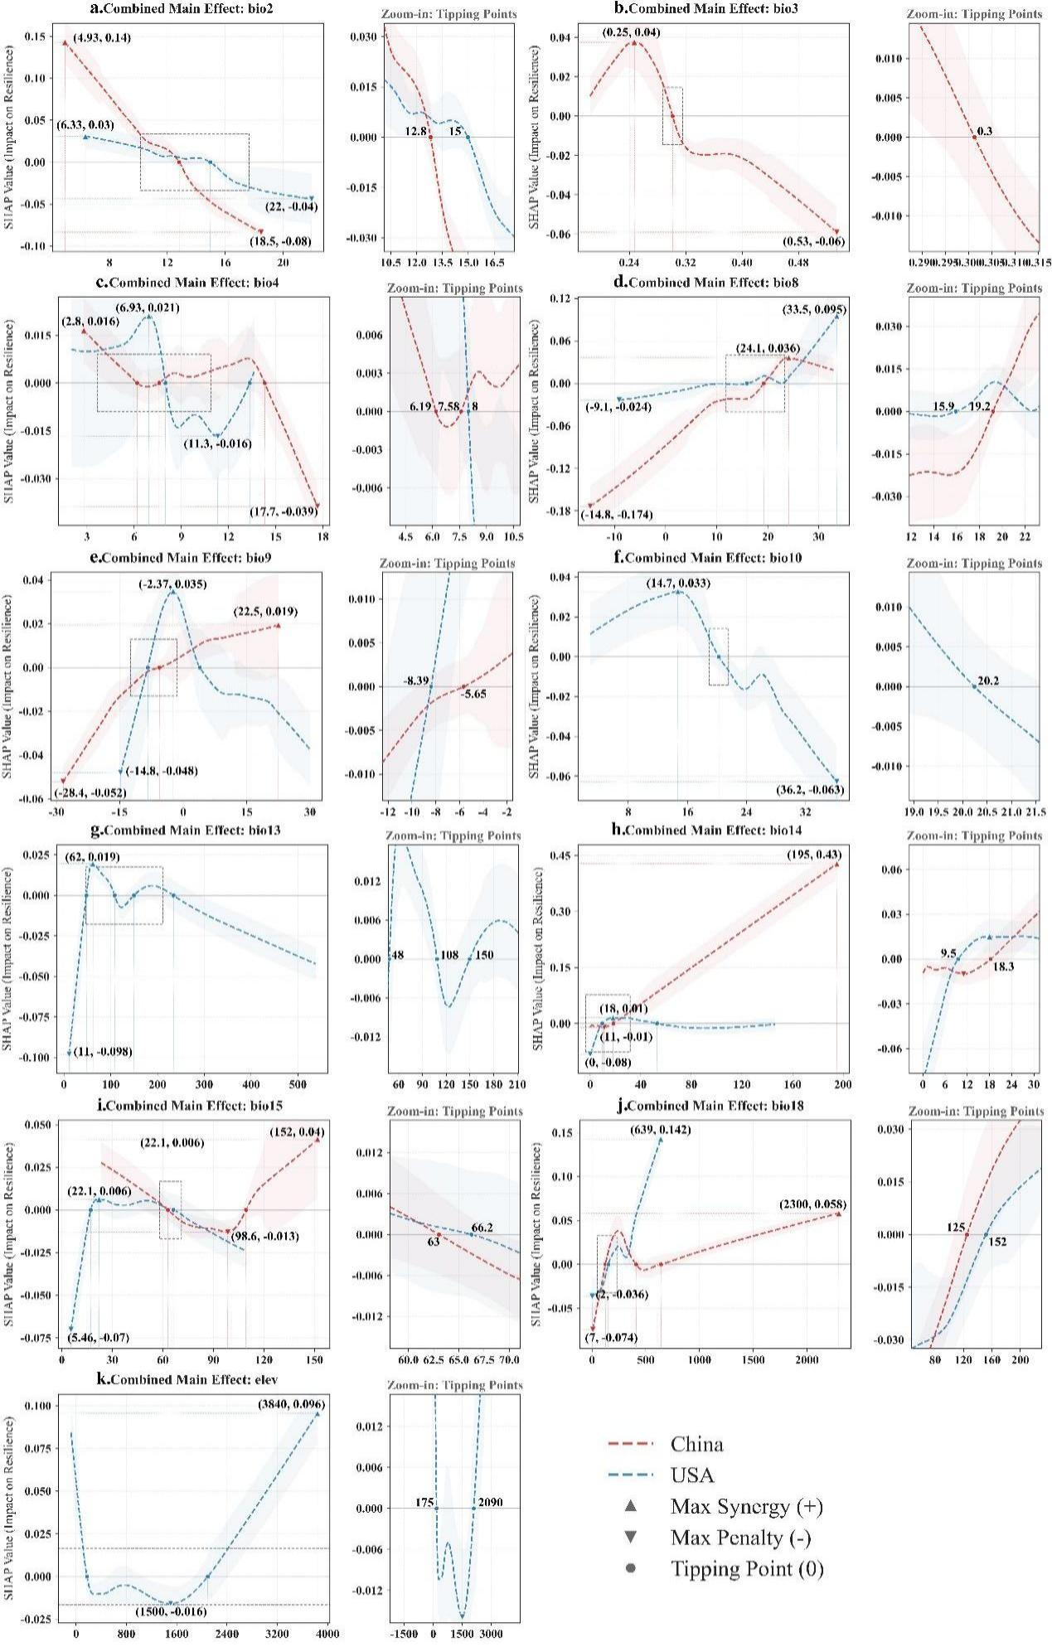
Figure 6. Response curves of environmental variables
(Source: original analysis by author)

3.4 Identification of Climate Refugia for Bird Community Resilience in China and the United States
Under future climate scenarios, climate refugia for avian community resilience in both China and the United States were primarily associated with complex mountainous landscapes and exhibited a tendency to shift toward higher latitudes and inland ecotonal regions. As greenhouse gas emissions intensified, the spatial dynamics of climate refugia became increasingly pronounced. Although both countries exhibited similar overall evolutionary trajectories, the magnitude and spatial extent of these changes differed.
Under the low-emission SSP1 scenario, the distribution patterns and degrees of change in climate refugia were broadly comparable between the two countries. Stable refugia occurred as fragmented patches within major mountain systems, with those in China concentrated in the hilly regions of southern China and parts of the Qinling–Daba Mountains (Fig. 7a), whereas those in the United States were mainly distributed across the Rocky Mountains and the Appalachian Mountains (Fig. 7b). Transitional and potential refugia in both countries were predominantly located within the ecotonal zones between southeastern coastal regions and adjacent lowland plains. Overall, under SSP1, climate refugia showed similar spatial patterns in both countries.
Under the intermediate-emission SSP2 scenario, spatial differentiation became more pronounced, with the expansion of refugia occurring over a larger spatial extent in the United States than in China. In China, stable refugia gradually coalesced into contiguous core areas within the Qinling–Daba Mountains and the mountainous regions of southern China, while transitional refugia began to exhibit a discernible northward shift (Fig. 7c). In the United States, stable refugia within the Rocky Mountains became substantially more connected, and transitional refugia expanded across the northern Great Plains and southern plains, with both the extent and area of expansion exceeding those observed in China during the same period (Fig. 7d).
Under the high-emission SSP5 scenario, the spatial configuration of climate refugia underwent extensive reorganization in both countries. Overall, stable refugia expanded within mountainous regions, transitional refugia shifted toward higher latitudes, and potential refugia in low-latitude coastal areas contracted markedly. However, these changes were considerably more pronounced in the United States than in China.
For stable refugia, intensified climate forcing did not lead to an overall collapse in area; instead, it promoted the expansion and concentration of highly resilient habitats within the core mountain systems of both countries. In China, stable refugia were centered on the Qinling–Daba Mountains and the mountainous regions of southern China, extending in a belt-like pattern toward higher elevations and the Taihang Mountains (Fig. 7e). In the United States, stable refugia expanded extensively throughout the Rocky Mountains, exhibiting substantially greater spatial connectivity and overall coverage than those in China (Fig. 7f).
Transitional refugia, representing habitats that provide intermediate-term climatic buffering, became increasingly concentrated within northern plains and ecotonal regions in both countries. In China, these refugia expanded northward into northeastern China, including the margins of the Greater and Lesser Khingan Mountains and the surrounding plains, as well as parts of southwestern China (Fig. 7e). In the United States, transitional refugia became widely distributed across the northern Great Plains and along the Gulf Coast (Fig. 7f).
In contrast, potential refugia exhibited marked contraction in low-latitude coastal regions of both countries. With continued warming, potential refugia in China were reduced to a few isolated patches along the southern coast (Fig. 7e), whereas those in the United States became largely confined to the southern Florida Peninsula and scattered remnants along the southeastern coastline (Fig. 7f).
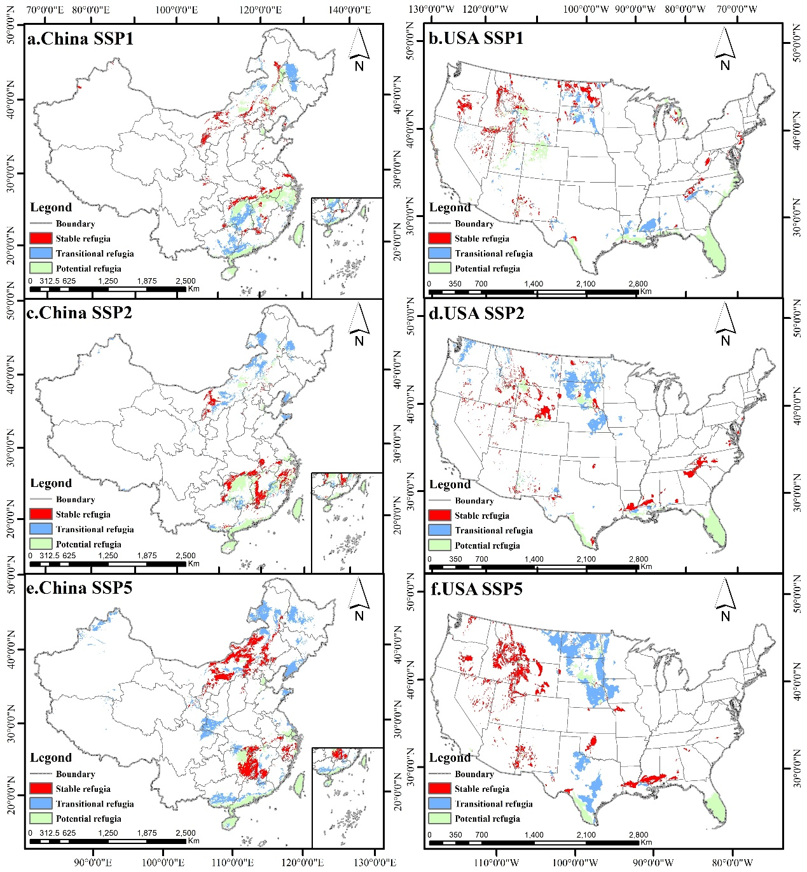
Figure 7. Spatial distribution of climate refugia for bird community resilience under different climate scenarios in China and the United States
(Source: original analysis by author)

Discussion
This study revealed substantial differences in the spatial baseline of avian community resilience between China and the United States, while demonstrating that both countries are likely to experience progressive and potentially irreversible degradation under intensified future climate change. At present, the United States is characterized by extensive and well-connected areas of moderate and high community resilience. This pattern is largely attributable to its vast inland plains and north–south-oriented mountain corridors, which provide continuous habitats and climate refugia for avian communities (Littlefield et a, 2017; Bateman et al, 2020). However, the pronounced contraction of highly resilient areas, particularly within the Rocky Mountains under severe climate forcing, highlights the vulnerability of conservation networks that have historically emphasized the preservation of pristine landscapes while overlooking functional habitat connectivity. In contrast, non-resilient areas currently dominate China, primarily owing to the long-term impacts of intensive human activities across the eastern monsoon region, which have substantially degraded avian habitats (Deng et al, 2025). Under future climate change, community resilience in southeastern China is projected to decline further, with the remaining highly resilient habitats shifting toward higher latitudes. This pattern likely reflects an adaptive response of bird communities seeking thermal equilibrium under accelerated warming (Lenoir et al, 2020). Collectively, these contrasting trajectories suggest that, although naturally formed conservation networks and government-driven spatial planning may differ in their initial buffering capacities, neither strategy alone is sufficient to prevent the long-term, climate-driven degradation of ecological resilience.
The contrasting large-scale spatial patterns are fundamentally associated with differences in the environmental mechanisms regulating community resilience. In China, changes in avian community resilience are predominantly governed by the main effects of individual environmental variables, whereas resilience in the United States is shaped primarily by complex interactions among multiple climatic factors. This contrast may be explained by the strong environmental constraints imposed by extreme hydrothermal conditions in the East Asian monsoon region, where crossing the tolerance threshold of a single climatic variable can trigger directional shifts in community resilience (Harris et al, 2018). By comparison, the complex topography and highly heterogeneous climatic regions of the United States (Carroll et al, 2018) facilitate stronger interactions and compensatory effects among multiple environmental drivers during community assembly and succession.
Threshold analyses further demonstrated that precipitation-related variables consistently exerted positive effects on community resilience after exceeding critical values in both countries. From a functional ecology perspective, alleviating water limitation enhances habitat carrying capacity, thereby increasing response diversity and strengthening overall community resilience (Storch et al, 2019). Notably, elevation in the United States exhibited a pronounced nonlinear threshold effect, whereby high-elevation environments shifted from constraining to strongly promoting community resilience beyond a critical altitude (Elsen et al, 2015). This finding suggests that mountainous regions can reshape local microclimates under intensified climate stress and function as effective climate refugia for maintaining community stability. Such asymmetric threshold responses are difficult to capture using conventional linear ecological models. By integrating advanced machine-learning algorithms with SHAP-based interpretation, our framework provides a more comprehensive understanding of ecological thresholds and nonlinear response mechanisms, highlighting the methodological advantages of explainable artificial intelligence for investigating community dynamics in heterogeneous landscapes.

Under high-emission scenarios, climate refugia in both China and the United States exhibited a convergent pattern characterized by concentration within mountainous regions and progressive shifts toward higher latitudes and inland areas. Stable refugia became increasingly aggregated within the core mountain systems of both countries, emphasizing the critical role of topographic complexity in buffering climatic stress and maintaining diverse habitats capable of supporting resilient biological communities. Conversely, the widespread contraction of potential refugia in low-latitude coastal regions signals a growing conservation challenge. This pattern indicates that protected-area networks delineated according to current geographic boundaries may become increasingly ineffective as species distributions continue to shift under climate change (Titley et al, 2021). Given the existing spatial mismatches between protected areas and future suitable habitats in both countries, conservation strategies should move beyond static reserve boundaries and prioritize the establishment of dynamic climate connectivity corridors linking highly resilient landscapes with emerging climatically suitable regions at higher latitudes. By systematically identifying and projecting the evolution of climate refugia across China and the United States, this study provides a spatially explicit foundation for developing forward-looking biodiversity conservation strategies in both countries and offers a broadly applicable framework for optimizing protected-area networks under future climate change.

Conclusion
This study integrated the MaxEnt model with the XGBoost–SHAP framework to systematically evaluate the spatial patterns of flagship bird community resilience in China and the United States under current and future climate scenarios. Furthermore, it elucidated the nonlinear relationships between community resilience and environmental drivers and identified the spatial distribution of climate refugia in both countries. The main findings are summarized as follows:
- Pronounced spatial heterogeneity in bird community resilience was observed between China and the United States under current climatic conditions. China was dominated by non-resilient areas with only limited high-resilience hotspots, whereas the United States exhibited substantially higher resilience coverage, characterized by extensive and contiguous moderately resilient regions.
- Bird community resilience declined markedly with increasing greenhouse gas emissions in both countries. In China, low-resilience areas expanded across the southeastern region, while the remaining highly resilient areas gradually shifted toward higher latitudes. In the United States, highly resilient regions within the Rocky Mountains experienced substantial contraction, accompanied by a pronounced expansion of non-resilient areas.
- The relationships between climatic drivers and community resilience differed considerably between the two countries. Bird community resilience in China was primarily governed by the independent main effects of individual environmental variables, whereas resilience patterns in the United States were largely shaped by complex interactions among multiple climatic factors.
- Hydrothermal variables exhibited distinct nonlinear threshold effects on bird community resilience. In both countries, precipitation became increasingly beneficial to resilience after exceeding critical threshold values. In addition, elevation exerted a unique buffering effect in high-altitude regions of the United States, partially mitigating the negative impacts of climate change on community resilience.
- Climate refugia displayed a consistent tendency to concentrate within complex mountainous landscapes and gradually shift toward higher latitudes and inland regions. Under high-emission scenarios, stable climate refugia in both countries became increasingly aggregated within major mountain systems, whereas potential refugia located in low-latitude coastal regions experienced substantial contraction.
In conclusion, these findings demonstrate that climate-change conservation strategies cannot follow a one-size-fits-all approach. Instead, conservation planning should prioritize areas with high or persistent resilience, protect and maintain connectivity among climate refugia, and adopt region-specific strategies according to differences in environmental sensitivity and future climate exposure.
Moreover, the contrasting environmental response mechanisms identified between China and the United States suggest that conservation priorities should also differ geographically. In China, conservation planning should focus on areas approaching critical climatic thresholds and prevent further habitat degradation, as results show that bird community resilience in China is primarily affected by single climate variables. By contrast, in the United States, maintaining elevational and landscape connectivity may be particularly important for preserving the buffering capacity of mountainous regions, given the positive contribution of elevation to community resilience and the projected contraction of high-resilience areas in the Rocky Mountains.

References (tentative)
- BirdLife International. (n.d.). Birds are very useful indicators for other kinds of biodiversity. https://datazone.birdlife.org/articles/birds-are-very-useful-indicators-for-other-kinds-of-biodiversity
- Bowen-Jones, E., & Entwistle, A. (2002). Identifying appropriate flagship species: The importance of culture and local contexts. Oryx, 36(2), 189–195. https://www.cambridge.org/core/journals/oryx/article/identifying-appropriate-flagship-species-the-importance-of-culture-and-local-contexts/93312046B3BD868342DE55331C3A066A
- Hallmann, C. A., Foppen, R. P. B., van Turnhout, C. A. M., de Kroon, H., & Jongejans, E. (2014). Declines in insectivorous birds are associated with high neonicotinoid concentrations. Nature, 511(7509), 341–343. https://www.nature.com/articles/nature13531
- Hannah, L., Midgley, G. F., Andelman, S., Araújo, M. B., Hughes, G., Martinez-Meyer, E., Pearson, R. G., & Williams, P. (2007). Protected area needs in a changing climate. Frontiers in Ecology and the Environment, 5(3), 131–138. https://esajournals.onlinelibrary.wiley.com/doi/10.1890/1540-9295(2007)5%5B131:PANIAC%5D2.0.CO;2
- Intergovernmental Science-Policy Platform on Biodiversity and Ecosystem Services. (2019). Global assessment report on biodiversity and ecosystem services of the Intergovernmental Science-Policy Platform on Biodiversity and Ecosystem Services. IPBES Secretariat. https://ict.ipbes.net/ipbes-ict-guide/data-and-knowledge-management/citations-of-ipbes-assessments/global-assessment
- Jenkins, C. N., Pimm, S. L., & Joppa, L. N. (2013). Global patterns of terrestrial vertebrate diversity and conservation. Proceedings of the National Academy of Sciences, 110(28), E2602–E2610. https://www.pnas.org/doi/10.1073/pnas.1302251110
- Wilson, M.C., Chen, XY., Corlett, R.T. et al. Habitat fragmentation and biodiversity conservation: key findings and future challenges. Landscape Ecol 31, 219–227 (2016). https://doi.org/10.1007/s10980-015-0312-3
- Morelli TL, Daly C, Dobrowski SZ, Dulen DM, Ebersole JL, Jackson ST, et al. (2016) Managing Climate Change Refugia for Climate Adaptation. PLoS ONE 11(8): e0159909. https://doi.org/10.1371/journal.pone.0159909
- Schmeller, D. S., Julliard, R., Bellingham, P. J., Böhm, M., Brummitt, N., Chiarucci, A., Couvet, D., Elmendorf, S., Forsyth, D. M., García Moreno, J., Gregory, R. D., Magnusson, W. E., Martin, L. J., McGeoch, M. A., Mihoub, J.-B., Pereira, H. M., Proença, V., van Swaay, C. A. M., Yahara, T., & Belnap, J. (2015). Towards a global terrestrial species monitoring program. Journal for Nature Conservation, 25, 51–57. https://www.sciencedirect.com/science/article/abs/pii/S1617138115000278?via%3Dihub
- Duan, H., Brown, M. J. M., Zhang, Y., Lu, L., Xing, K., Yang, Y., Zhou, H., & Wan, H. (2026). Linking dynamic habitat indices to resident bird richness: Evidence from a national-scale analysis in China. Remote Sensing, 18(3), 493. https://doi.org/10.3390/rs18030493
- Dong, J., Matthews, S. N., Shumar, M. B., & Peterman, W. E. (2025). Spatially varying drivers of temporal β diversity in forest avian communities. Ecology and Evolution, 15(10), e72359. https://doi.org/10.1002/ece3.72359
- Kroner, R. E. G., Krithivasan, R., & Mascia, M. B. (2016). Effects of protected area downsizing on habitat fragmentation in Yosemite National Park (USA), 1864–2014. Ecology and Society, 21(3). https://www.ecologyandsociety.org/vol21/iss3/art22/
- Mi, C., Song, K., Ma, L., Xu, J., Sun, B., Sun, Y., Liu, J., & Du, W. (2023). Optimizing protected areas to boost the conservation of key protected wildlife in China. The Innovation, 4(3), 100424. https://doi.org/10.1016/j.xinn.2023.100424
- Dasgupta, S., Blankespoor, B., & Wheeler, D. (2026). Toward better conservation: A spatial analysis of species occurrence data from the Global Biodiversity Information Facility. Earth System Science Data, 18(3), 2371–2390. https://doi.org/10.5194/essd-18-2371-2026
- Sun, Z., Zhao, T., Hu, S., Chen, G., Zhu, W., Peng, X., & Su, S. (2025). Integrating climate change and fine-scale habitat suitability to assess amphibian range shift in Mount Emei, China. Frontiers in Zoology, 22, 16. https://doi.org/10.1186/s12983-025-00570-6
- Hughes, A. C., Orr, M. C., Yang, Q., Qiao, H., & others. (2021). Effectively and accurately mapping global biodiversity patterns for different regions and taxa. Global Ecology and Biogeography, 30(7), 1375–1388. https://doi.org/10.1111/geb.13304
- Luan, J., Zhang, C., Xu, B., Xue, Y., & Ren, Y. (2020). The predictive performances of random forest models with limited sample size and different species traits. Fisheries Research, 227, 105534. https://doi.org/10.1016/j.fishres.2020.105534
- Gelete, T. B., Tulu, D., Yasin, K. H., & Kebede, E. (2025). Machine learning predictions of climate change effects on nearly threatened bird species (Crithagra xantholaema) habitat in Ethiopia for conservation strategies. Scientific Reports, 15(1), 36972. https://doi.org/10.1038/s41598-025-20952-4
- Dragonetti, C., Thuiller, W., Guéguen, M., Renaud, J., Visconti, P., & Di Marco, M. (2026). Impact of global change on the distribution of mountain mammals and birds. Conservation Biology, e70339. https://www.researchgate.net/publication/405804617_Impact_of_global_change_on_the_distribution_of_mountain_mammals_and_birds
- Ji, P., Su, R., Wu, G., Xue, L., Zhang, Z., Fang, H., Gao, R., Zhang, W., & Zhang, D. (2025). Projecting future wetland dynamics under climate change and land use pressure: A machine learning approach using remote sensing and Markov chain modeling. Remote Sensing, 17(6), 1089. https://doi.org/10.3390/rs17061089
- Guisan, A., & Zimmermann, N. E. (2000). Predictive habitat distribution models in ecology. Ecological Modelling, 135(2–3), 147–186. https://www.sciencedirect.com/science/article/pii/S0304380000003549?via%3Dihub
- Phillips, S. J., Dudík, M., & Schapire, R. E. (2004). A maximum entropy approach to species distribution modeling. In Proceedings of the 21st International Conference on Machine Learning (pp. 655–662). Association for Computing Machinery. https://dl.acm.org/doi/10.1145/1015330.1015412
- Phillips, S. J., Anderson, R. P., & Schapire, R. E. (2006). Maximum entropy modeling of species geographic distributions. Ecological Modelling, 190(3–4), 231–259. https://www.sciencedirect.com/science/article/pii/S030438000500267X?via%3Dihub
- Luo, M., Wang, H., & Lyu, Z. (2017). Evaluating the performance of species distribution models Biomod2 and MaxEnt using the giant panda distribution data. Ying Yong Sheng Tai Xue Bao, 28(12), 4001–4006. https://link.cnki.net/doi/10.13287/j.1001-9332.201712.011
- Merow, C., Smith, M. J., & Silander, J. A., Jr. (2013). A practical guide to MaxEnt for modeling species’ distributions: What it does, and why inputs and settings matter. Ecography, 36(10), 1058–1069. https://nsojournals.onlinelibrary.wiley.com/doi/10.1111/j.1600-0587.2013.07872.x
- West, A. M., Kumar, S., Brown, C. S., Stohlgren, T. J., & Bromberg, J. (2016). Field validation of an invasive species MaxEnt model. Ecological Informatics, 36, 126–134. https://doi.org/10.1016/j.ecoinf.2016.11.001
- Zhang, Y., Tang, J., Ren, G., Zhao, K., & Wang, X. (2021). Global potential distribution prediction of Xanthium italicum based on MaxEnt model. Scientific Reports, 11(1), 16545. https://doi.org/10.1038/s41598-021-96041-z
- Liu, C., Berry, P. M., Dawson, T. P., & Pearson, R. G. (2005). Selecting thresholds of occurrence in the prediction of species distributions. Ecography, 28(3), 385–393. https://nsojournals.onlinelibrary.wiley.com/doi/10.1111/j.0906-7590.2005.03957.x
- Ramos, R. S., Kumar, L., Shabani, F., & Picanço, M. C. (2019). Risk of spread of tomato yellow leaf curl virus (TYLCV) in tomato crops under various climate change scenarios. Agricultural Systems, 173, 524–535. https://www.sciencedirect.com/science/article/abs/pii/S0308521X18305870?via%3Dihub
- Li, D., Li, Z., Liu, Z., Yang, Y., Khoso, A. G., Wang, L., & Liu, D. (2022). Climate change simulations revealed potentially drastic shifts in insect community structure and crop yields in China’s farmland. Journal of Pest Science, 95, 1–15. https://link.springer.com/article/10.1007/s10340-022-01479-3?utm_source=researchgate.net&utm_medium=article
- Baskin, Y. (1997). The work of nature: How the diversity of life sustains us. Island Press. https://books.google.com/books?hl=zh-CN&lr=&id=BMnNEQAAQBAJ&oi=fnd&pg=PT8&dq=31.Baskin,+Y.+(1997).+The+work+of+nature:+How+the+diversity+of+life+sustains+us.&ots=SfRhX5WRRE&sig=Xe54VV82bZIHJInNLgCTH1dOgzU
- Carmona, C. P., Tamme, R., Pärtel, M., de Bello, F., Brosse, S., Capdevila, P., González-M., R., González-Suárez, M., Salguero-Gómez, R., Vásquez-Valderrama, M., & Toussaint, A. (2021). Erosion of global functional diversity across the tree of life. Science Advances, 7(13), eabf2675. https://doi.org/10.1126/sciadv.abf2675
- Mori, A. S., Furukawa, T., & Sasaki, T. (2013). Response diversity determines the resilience of ecosystems to environmental change. Biological Reviews, 88(2), 349–364. https://onlinelibrary.wiley.com/doi/10.1111/brv.12004
- Lu, Z., Zhang, S., Yu, X., & Fu, Y. (2026). Spatio-temporal evolution and influencing factors of ecological resilience in the Yellow River Basin. Frontiers in Environmental Science, 14, 1778474. https://doi.org/10.3389/fenvs.2026.1778474
- Wu, L., Sun, C., & Fan, F. (2021). Estimating the characteristic spatiotemporal variation in habitat quality using the InVEST model: A case study from Guangdong–Hong Kong–Macao Greater Bay Area. Remote Sensing, 13(5), 1008. https://www.mdpi.com/2072-4292/13/5/1008?utm_source=researchgate.net&utm_medium=article
- Littlefield, C. E., McRae, B. H., Michalak, J. L., Lawler, J. J., & Carroll, C. (2017). Connecting today’s climates to future climate analogs to facilitate movement of species under climate change. Conservation Biology, 31(6), 1397–1408. https://conbio.onlinelibrary.wiley.com/doi/epdf/10.1111/cobi.12938
- Bateman, B. L., Wilsey, C., Taylor, L., Wu, J., Pidgeon, A. M., & Radeloff, V. C. (2020). North American birds require mitigation and adaptation to reduce vulnerability to climate change. Conservation Science and Practice, 2(8), e242. https://doi.org/10.1111/csp2.242
- Deng, J., Zhu, Y., Luo, Y., Zhong, Y., Tu, J., Yu, J., & He, J. (2025). Urbanization drives biotic homogenization of the avian community in China. Integrative Zoology, 20(1), 60–72. https://doi.org/10.1111/1749-4877.12815
- Lenoir, J., Bertrand, R., Comte, L., Bourgeaud, L., Hattab, T., Murienne, J., & Grenouillet, G. (2020). Species better track climate warming in the oceans than on land. Nature Ecology & Evolution, 4(8), 1044–1059. https://doi.org/10.1038/s41559-020-1198-2
- Harris, R. M. B., Beaumont, L. J., Vance, T. R., Tozer, C. R., Remenyi, T. A., Perkins-Kirkpatrick, S. E., Mitchell, P. J., Nicotra, A. B., McGregor, S., Andrew, N. R., Letnic, M., Kearney, M. R., Wernberg, T., Hutley, L. B., Chambers, L. E., Fletcher, M.-S., Keatley, M. R., Woodward, C. A., Williamson, G., … Bowman, D. M. J. S. (2018). Biological responses to the press and pulse of climate trends and extreme events. Nature Climate Change, 8(7), 579–587. https://doi.org/10.1038/s41558-018-0187-9
- Carroll, C., Parks, S. A., Dobrowski, S. Z., & Roberts, D. R. (2018). Climatic, topographic, and anthropogenic factors determine connectivity between current and future climate analogs in North America. Global Change Biology, 24(11), 5318–5331. https://doi.org/10.1111/gcb.14373
- Storch, D., & Okie, J. G. (2019). The carrying capacity for species richness. Global Ecology and Biogeography, 28(10), 1519–1532. https://www.researchgate.net/publication/335153639_The_carrying_capacity_for_species_richness
- Elsen, P. R., & Tingley, M. W. (2015). Global mountain topography and the fate of montane species under climate change. Nature Climate Change, 5(8), 772–776. https://doi.org/10.1038/nclimate2656
- Titley, M. A., Butchart, S. H. M., Jones, V. R., Whittingham, M. J., & Willis, S. G. (2021). Global inequities and political borders challenge nature conservation under climate change. Proceedings of the National Academy of Sciences, 118(7), e2011204118. https://doi.org/10.1073/pnas.2011204118

